What is an ER diagram (ERD)?
First of all, what is an Entity Relationship Diagram?
Entity Relationship Diagram, also known as ERD, ER Diagram or ER model, is a type of structural diagram for use in database design. An ERD contains different symbols and connectors that visualize two important information: The major entities within the system scope, and the inter-relationships among these entities.
And that's why it's called "Entity" "Relationship" diagram (ERD)!
When we talk about entities in ERD, very often we are referring to business objects such as people/roles (e.g. Student), tangible business objects (e.g. Product), intangible business objects (e.g. Log), etc. "Relationship" is about how these entities relate to each other within the system.

What do ERD's consist of?
An entity relationship diagram consists of 5 main things
The parts of an ERD
Name | Definition | Shape
Entity | An entity is a definable thing, or concept within a system. Sometimes it corresponds with an Object in programming, but it doesn't have too. An example would be a student, profile or transaction.  - The difference between a dependent entity and an independent entity lies in how the primary key of the entity is structured.  - The independent entity is so named because it has no primary key dependencies on any other entity, or in other words, the primary key contains no foreign key columns from other entities. | Typically a rounded rectangle:
Attribute | An attribute represents the property of characteristic of the entity that holds it. These become the columns of your database. In an ERD they are below the Entity title | Attributes are listed under the entity title: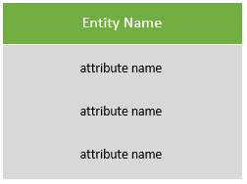
Primary Keys (PK) | A primary key is a special attribute, it uniquely identifies a record in a table. There cannot be 2 primary keys with the same value. In and ERD they are highlighted attributes that are floated to the top of the attributes | PK attributes are floated to the top of the attributes section and usually labeled with a PK, or a tiny key ():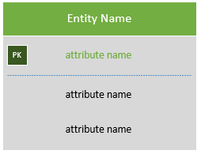
Relationships | A relationship is a link or association between two entities. For example, if you had a table of students, they would have a relationship with a course.  Typically you'll see 2 types of relationships in an ERD:  Strong (Identifying) Relationship  - Child entity is existence-dependent on parent  - PK of Child Entity contains PK component of Parent Entity  - Usually occurs utilizing a composite key for primary key, which means one of this composite key components must be the primary key of the parent entity.  Weak (Non-Identifying) Relationship  - Entity is existence-independent of other entities  - PK of Child doesn’t contain PK component of Parent Entity | A solid line if the relationship is an identifying relationship:    A dotted line if there is a weak, or non-identifying relationship:  
Cardinality | Cardinality defines the number of occurrences in one entity that is associated with the number of occurrences in another. A classic example would be one team has many players a (one to many) | In an ERD we use crows foot notation to represent cardinality:  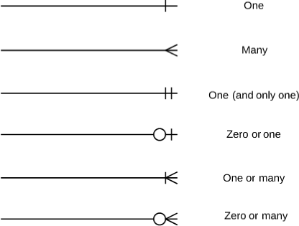

Types of ERD

A Summary
ERD features | Conceptual | Logical | Physical
Entity (Name) | Yes | Yes | Yes
Relationship | Yes | Yes | Yes
Columns |  | Yes | Yes
Column's Types |  | Optional | Yes
Primary Key |  |  | Yes
Foreign Key |  |  | Yes

Conceptual
A conceptual ERD models business objects that should exsist in a system it's used to give an overall view of the system. It defines what entites exist, but NOT which tables. Cardinality is NOT represented in a conceptual model.

Logical
A logical data model, provides a more detailed version of a conceptual ERD, but takes the model a step further by identifying attributes

Physical
The physical data model represents an actual blueprint of a relational database. These are model examples that this course will primarily focus on, they contain the most detail including entities, relationships, columns, column data types, primary and foreign key relationships as well as detailed cardinality.

Example:
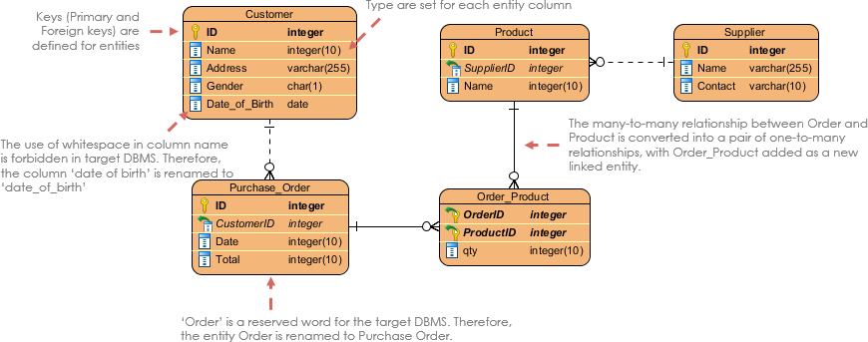
Source: https://cdn.visual-paradigm.com/guide/data-modeling/what-is-erd/12-physical-data-model-example.png

